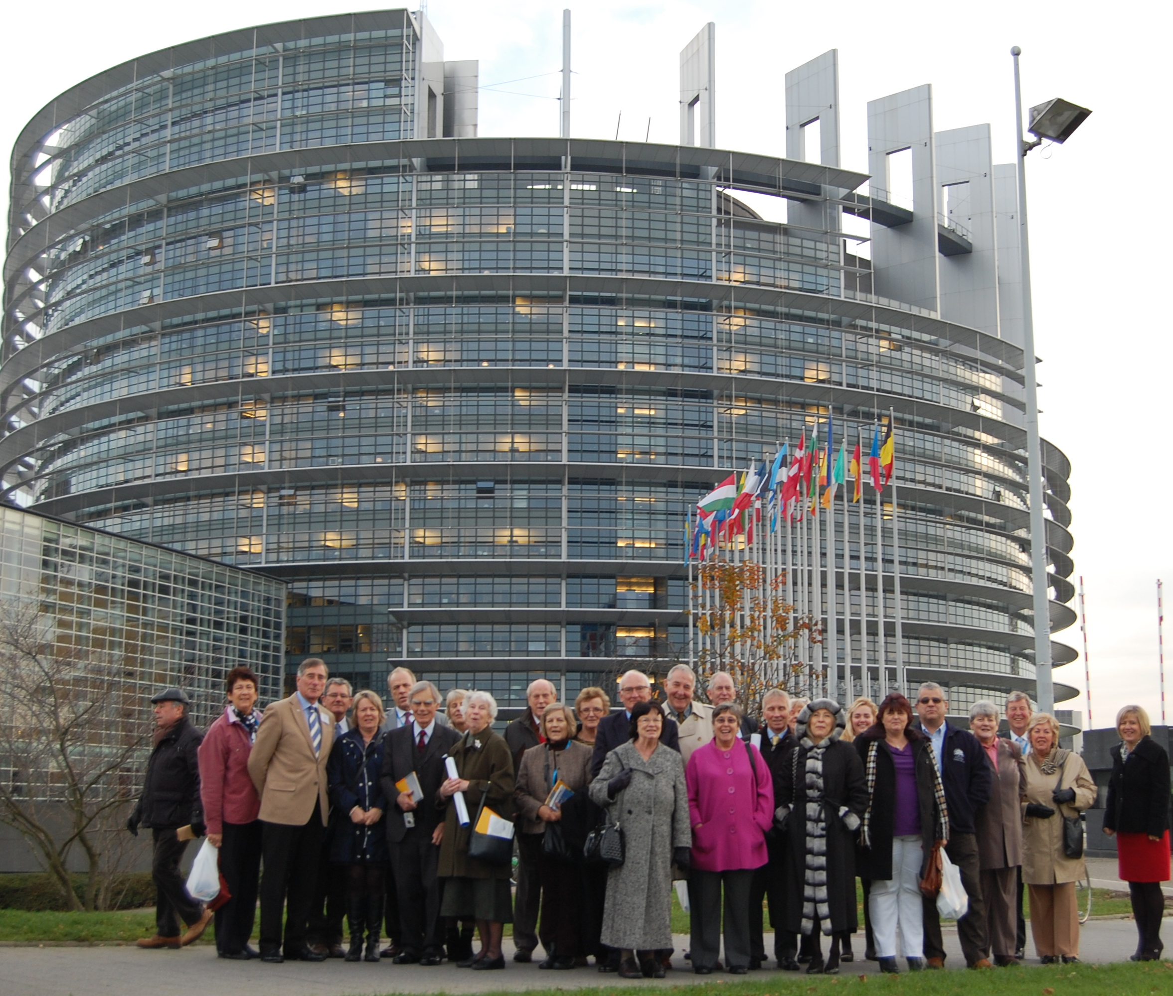
2016 Strasbourg Visit
Monday 24th – Friday 28th October

The West Midlands Region is again joining together with the South West to organise a visit to the European Parliament after the successful trip last June. The trip will provide a chance to meet MEPs from different nations and to see an example of the work carried out during the monthly plenary sessions in Strasbourg. Anthea’s and Julie’s teams will escort you on this 5 day trip departing on Monday 24th October and returning on Friday 28th October 2016.

We will have the exclusive use of an executive coach with the added benefit of extra leg room and hostess service.  We have negotiated an extremely competitive price for the week:  £405 per person sharing twin / double room –  based on minimum of 25 passengers  £100 per person single supplement (levied by the hotels)  We have student places available at a reduced rate – please enquire for more details | 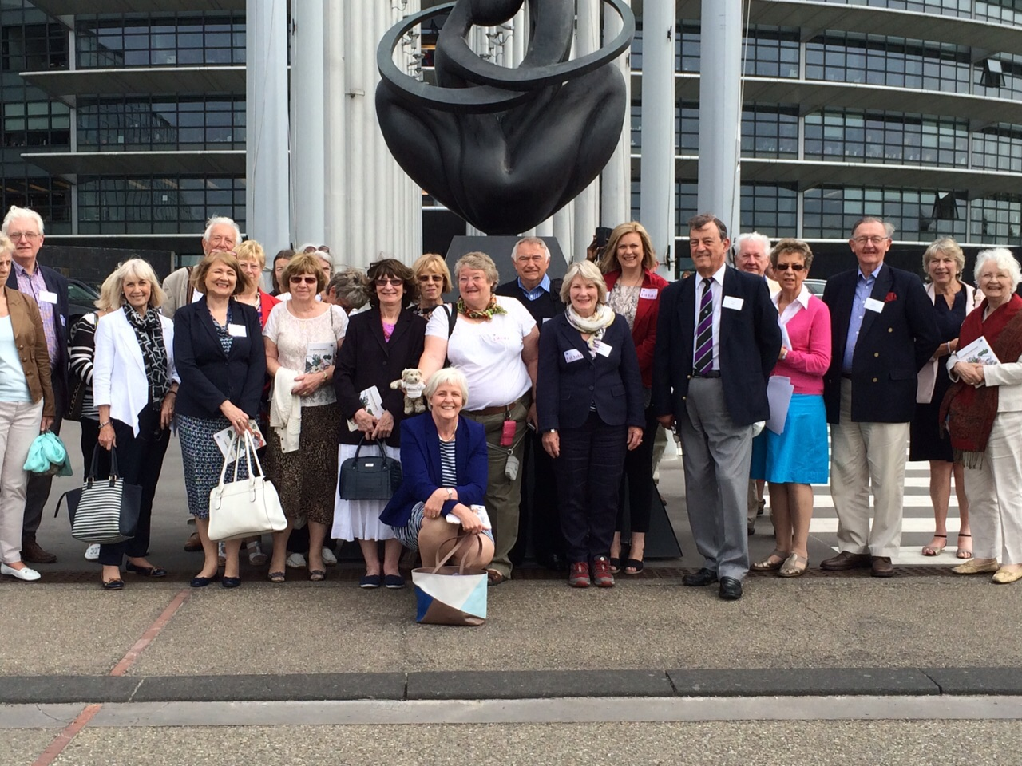
The price includes:
- Executive Coach Travel - with extra leg room and hostess service - for the five days
- 3 pick-up points - Bristol Parkway Station, M4 J17 at The Stanton Manor Hotel and Membury or Reading Services (Eastbound). Return drop-off will be the same but Westbound at Membury or Reading. Also with an option to arrange a pick-up at J5 M5 (depending on numbers)
- Return Eurotunnel Crossings Folkestone / Calais
- 1 night Dinner, Bed & Breakfast at Best Western Plus Metz Technopole, Metz
- A city tour in Strasbourg followed by free time to explore
- 2 nights Bed & Breakfast in The Mercure Strasbourg Aeroport Hotel, Strasbourg
- Dinner with your MEPs at The Mercure Strasbourg Aeroport Hotel
- Visit to the European Parliament to include time in the Chamber, a brief talk by MEPs and the Visitor Centre and lunch with the MEPs
- Dinner in a traditional Strasbourg restaurant with the MEPs
- Return journey visiting the pretty town of Lahr for the Chrysanthemum Festival, travelling on through the Champagne Region arriving in the historic city of Reims
- 1 night Bed & Breakfast at the Mercure Reims Centre Cathédrale with evening meal at the hotel
- All road tolls & taxes

As with all trips, at times there will be a requirement to walk some distance, particularly in Strasbourg where many of the streets are cobbled and pedestrianised.

Places are limited and will be allocated on a first come first served basis. Call or email today to ensure that you don't miss out. We will require a £40 non-refundable deposit to secure your place. Cheques should be made payable to Julie Girling – this is an account Julie has set up purely for the payment of trips and visits involving constituents, not for her own use.

For more information, please contact Anthea’s office on 01989 769544, email helen@antheamcintyre.com or Dan’s office on 01926 930683, email rebecca@danieldaltonmep.co.uk and the team will be pleased to provide more information.
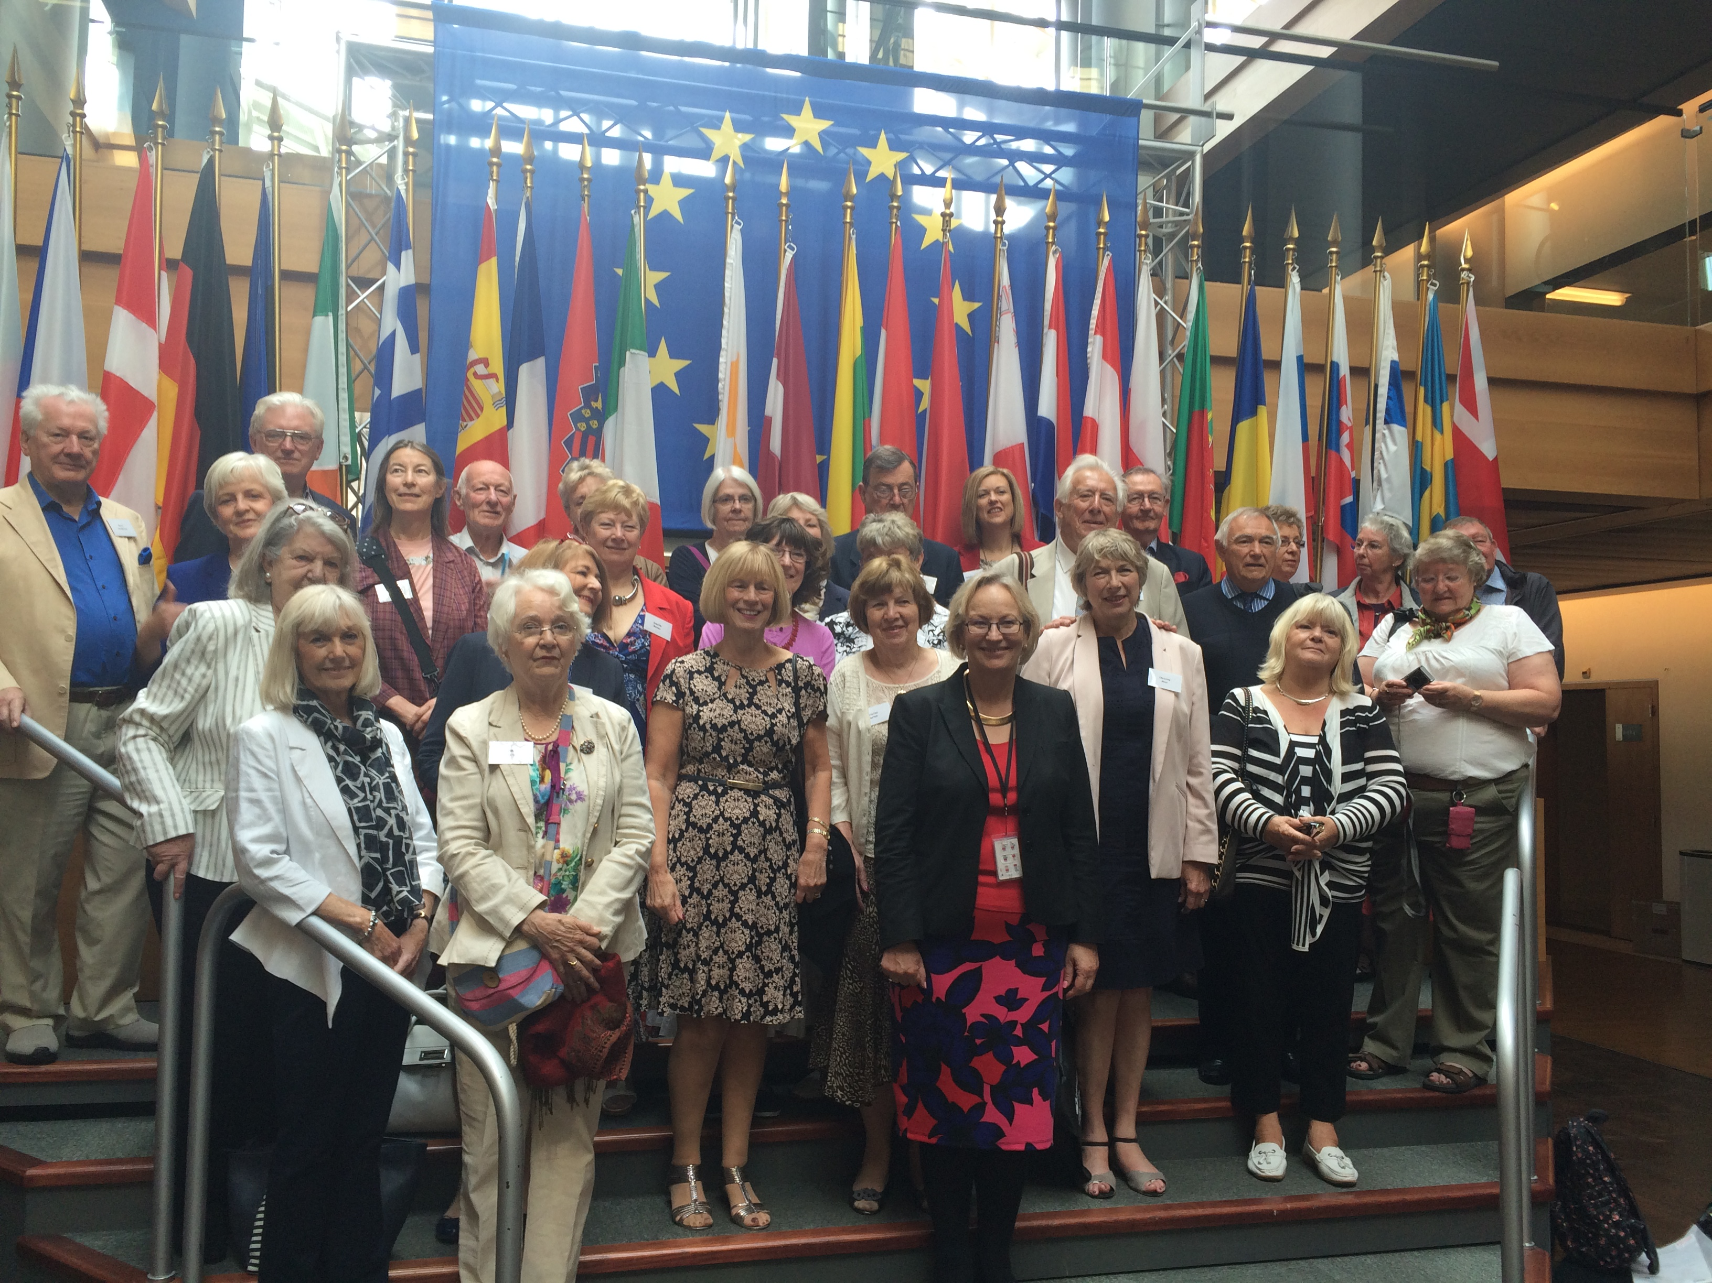 | We look forward to welcoming you on our 2016 trip to Strasbourg.  . 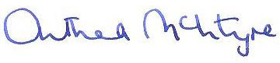   Anthea McIntyre MEP Dan Dalton MEP

